POSITION AVAILABLE
PART-TIME ASSISTANT RESEARCH ARCHIVIST
SEATTLE ARCH 4 CULTURE HERITAGE PROGRAM GRANT

Overview
Seattle ARCH, an organization dedicated to preserving and sharing the history of Seattle’s Freeway Revolt, is seeking a limited-term, part-time assistant research archivist. This position is funded by a 4Culture/King County Lodging Tax grant awarded to Seattle ARCH for the purpose of identifying, locating and describing relevant information repositories and resources to be included in a comprehensive, annotated digital directory.

The Seattle Freeway Revolt Resource Directory will enable students, researchers, educators and others to gain access to the history of this major citizen movement. The directory will include an enhanced bibliography, timeline, and descriptive inventory of major information sources, and will be available in both print and electronic formats through the Seattle Public Library’s Special Collections.

The Assistant Research Archivist is expected to work independently on assigned research tasks in consultation with the primary 4Culture-funded research archivist and Seattle ARCH project coordinators. Our team has identified several specific repositories and topics that require further investigation and documentation for inclusion in the digital directory. We will provide an extensive list of related subjects, insdividuals and timeframes to assist in this effort, but expect the research effort will entail independent discovery, documentation and synthesis of information found in multiple repositories.

Qualifications

We are seeking an Information School student with demonstrated knowledge of archival concepts, methodology and techniques, including the ability to create finding aids in compliance with professional standards. He/she must be able to work independently, meet established timeframes, coordinate efforts with a small project team and seek information from information professionals as needed. He/she must provide own computer and access to internet resources to collect, format and store information prior to inclusion in directory. Occasional conference calls or in-person meetings will be required for project coordination.

Hours and Compensation

This position is available for 8-10 hours per week between March and May (10-12 weeks total, not to exceed 100 hours). Compensation is $20 per hour.

How To Apply

Interested candidates should submit a resume by March 15, 2017, to Priscilla Arsove, parsove@gmail.com. Please include a phone number and good time(s) to reach you.

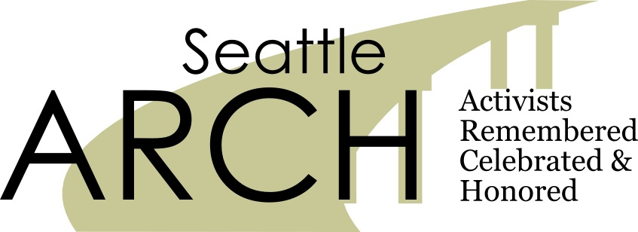
Seattle ARCH is an Associated Program of Shunpike

