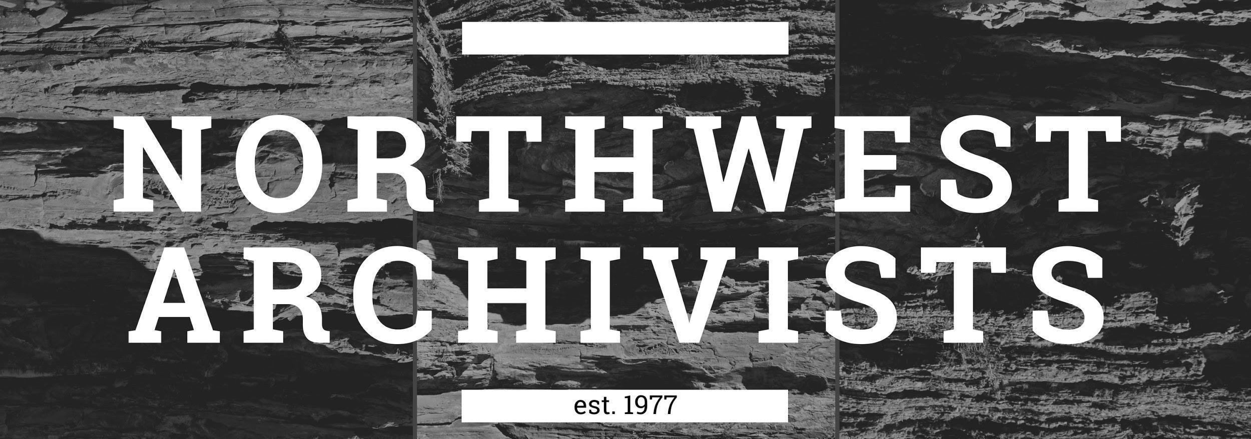

Archivist-in-Residence
Application Form

For insight into the application process, please note there is an informational webinar provided at the bottom of this webpage: https://northwestarchivistsinc.wildapricot.org/archivistinresidence

Applicant Name:
Email:
Phone:
Graduate program name and school:
Graduation date:

Host Organization Name:
Host Organization Location:

Supervisor at proposed location:
Title:
Email:
Phone:

Q. How did you hear about the NWA Archivist-in-Residence program?

Please provide a brief description of the proposed residency project and clearly identify two to three outcomes or products that will be completed by the end of the residency (up to 250 words):

Anticipated Timeline of Residency: (Award notification will occur May 2023. You may begin upon receiving notification and must be completed by December 31, 2023).

Please provide a brief description of your project’s contingency plan for any potential disruptions. For example: a global pandemic, a family emergency, an environmental disaster that requires evacuation, etc. (up to 100 words):
Project Budget: Use the MIT Living Wage Calculator (http://livingwage.mit.edu/) to calculate the living wage and project budget. Document the following factors in a format similar to the provided Sample budgets on the next page. We encourage you to get as close to the award ceiling as possible.

Note: If the Resident will be living and working remotely in a geographic location separate from the Host institution, please use the higher of the two MIT Living Wage rates.

Sample Budgets
Example 1:
Project based in Twin Falls, Idaho
Minimum wage: $7.25
Calculated living wage: $15.65
- Completed masters degree and 1 year of experience
- Project requiring technical expertise and independent work
Total hourly wage: $20.50
Hours: 28/week for 12 weeks
Requested funding total: $6,888.00

Example 2:
Project based in Seattle, Washington
Minimum wage: $17.27
Calculated living wage: $21.42
- First year graduate student with minimal archival experience
- Project requiring extensive oversight and mentorship
Total hourly wage: $23.00
Hours: 25/week for 12 weeks
Requested funding total: $6,900.00

Please include the following information as part of your budget:

- Minimum wage in project location
- Estimated cost of living in project location
- Completed level of education and relevant work experience
- Expected project level of technical expertise and independent work
- Other factors, such as institutional policies, that influence wage calculations
- Total hourly wage with a breakdown of proposed hours per week and estimated number of weeks
- Requested funding total

Resident Applicant
- What skills, education, and/or previous experience do you have that will be utilized for this project (up to 250 words)?

- How is this project applicable to your career goals and what skills do you hope to strengthen (up to 250 words)?

- How do you see this project benefiting the host institution (up to 100 words)?

Host Institution
- Please provide a brief description of the organization and the archival materials relevant to the project (up to 100 words).

- What resources are required for the residency and how will the host organization provide those resources? If this is a remote opportunity, please be sure to describe how access to collection materials and tools will be facilitated (up to 100 words).

- Please list any current or past participation in Northwest Archivists or an equivalent regional or national professional organization dedicated to historical or cultural preservation and/or education (up to 250 words).

- How do you feel this residency will help you further your organization’s commitment to ethical labor practices and the equitable treatment of students and new professionals (up to 500 words)? Please note, we do not accept answers that only cite the organization’s Diversity, Equity, and Inclusion statements. If this occurs, you will receive a “0” score for this section. You may reference DEI statements in addition to directly addressing labor practices at your organization and how the organization is working to improve their labor practices and areas of labor compensation.

- How does the host site supervisor commit to supporting the Archivist-in-residence during this project on a day-to-day basis? Please describe what training and supervision will look like. (up to 250 words):

For final consideration, the proposed resident and host site should jointly complete the application form in full and submit it along with a 1 to 2-page resume (from the proposed resident) to: rachael@relicura.com. Please note the deadline is April 14, 2023 at 11:59pm Pacific.

Contact
Questions may be directed to the NWA Paid Internship Committee at: rachael@relicura.com

The NWA Paid Internship Committee would like to thank NWA membership and our Platinum-level sponsors for their support of the Archivist-in-Residence program.

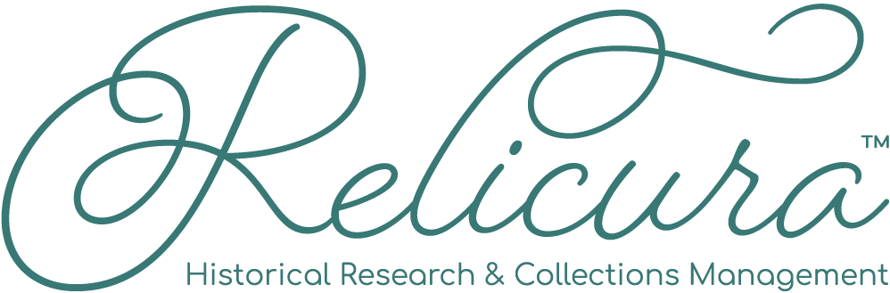

A special thank you to our Gold-level sponsors for their support of the Archivist-in-Residence program.

Thank you to our Silver-level sponsors for their support of this program.

We would also like to thank our returning Bronze-level sponsors.

